OBITUARY

LOREN CUNNINGHAM, FOUNDER OF YOUTH WITH A MISSION (YWAM) WENT TO BE WITH JESUS ON OCTOBER 6, 2023 AT THE AGE OF 88

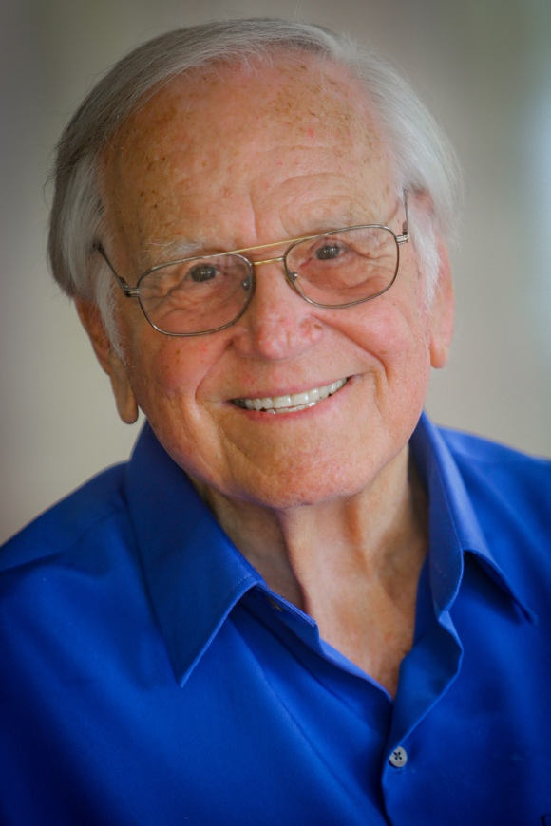
Loren was the first person in history to travel for the sake of Christ and the Great Commission to every sovereign nation on earth, all dependent countries, and more than 100 territories (Mark 16:15). Now he has added one more "stamp" to his well-worn passport: HEAVEN!

Loren is often called the "de-regulator of missions" because he broke the 1960s missionary paradigm by creating opportunities for Youth to serve short-term, interdenominationally, globally and unsalaried. This foresight opened the floodgates so that millions could come FROM everywhere and go TO everywhere as missionaries around the globe to proclaim the truth of God and display His love.

The ministry he founded, Youth With A Mission, an ever-expanding global missions movement born in 1960, has reached into every nation on earth through evangelism, training and mercy ministries (YWAM.org). Tens of thousands of full-time staff participate from 200+ countries and various denominations and Christian traditions, serving at over 2,000 YWAM locations in nearly 200 nations. Millions have served in YWAM programs as students, short-term volunteers and full-time staff.

Many have credited YWAM as being among the world's largest mission movements. But when presented with this claim, Loren always deflected the glory to Jesus, saying, "Well, however large it is, it's not large enough because Jesus' last commandment to reach the whole world with the Gospel has not been completed." He was well-known for his call to build bridges of unity within the body of Christ, always quick to recognize the scores of other missions and churches serving together in partnership.
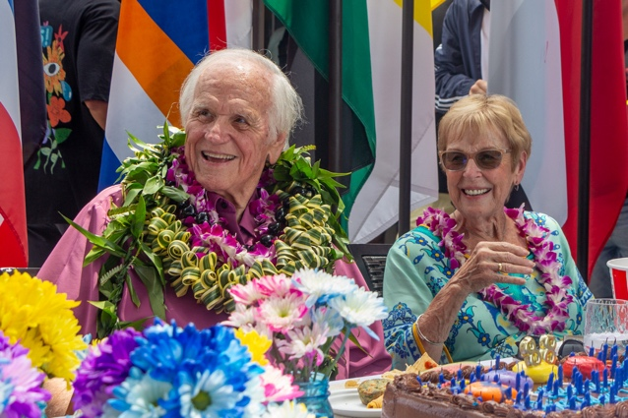
A humble and godly man with a wonderful sense of humor, Loren was approachable and pioneered YWAM to be decentralized, emphasizing "Joe and Jane YWAMer," not a leadership hierarchy. When people would refer to him as "doctor" or "reverend," he would quickly say, "Please just call me Loren."

The Vision of the Waves

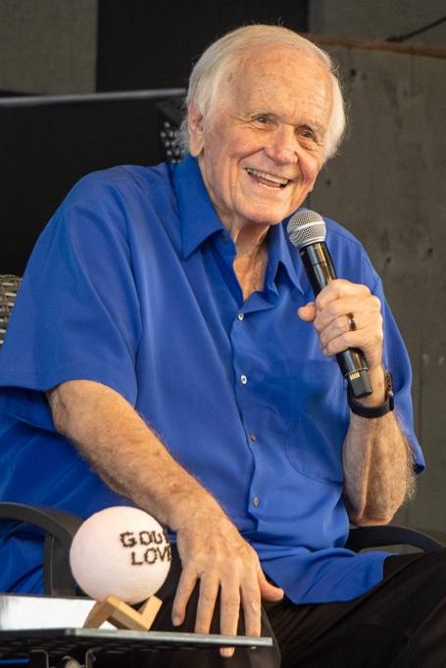
Loren's call to the Great Commission came while kneeling at the altar during a brush arbor revival meeting in 1948 at the age of 13. God spoke to him through Mark 16:15: "Go into all the world and preach the Gospel to every creature."

This personal call was confirmed by a vision – a mental movie – that he saw as he was preparing to minister in the Bahamas in 1956 (YWAMValues.com). He was staying in a missionary's home, kneeling beside the bed, praying in preparation to speak that night. He says, "Suddenly, I was looking at a map of the world, only the map was alive and moving! I could see all the continents, and waves were crashing onto their shores. Each wave went onto a continent, then receded, then came up further until it covered the continent completely. The waves became young people–kids my age and even younger–covering all the continents of the globe. They were talking to people on street corners and outside bars. They were going from house to house and preaching the Gospel. They came from everywhere and went everywhere, caring for people. Then, just as suddenly as it had come, the scene was gone." (Excerpt from Is That Really You, God? by Loren Cunningham with Janice Rogers, YWAM Publishing.)

Global initiatives launched under Loren's leadership include King’s Kids International, the University of the Nations, YWAM Ships (28 vessels currently serve the most isolated islands and coastlands), and myriads of other ministries birthed by leaders he inspired.

The Christian Magna Carta

The Christian Magna Carta, penned by Loren in 1981, included both his personal goals and YWAM's corporate goals that are implicit in the Gospel:

Everyone on earth has the right to:
1. Hear and understand the Gospel of Jesus Christ,
2. Have a Bible available in his/her own language,
3. Have a Christian fellowship available nearby to be able to meet for fellowship regularly each week and to have biblical teaching and worship with others in the body of Christ,
4. Have a Christian education available for their children,
5. Have the basic necessities of life: food, water, clothing, shelter, and health care,
6. Lead a productive life of fulfillment spiritually, mentally, socially, emotionally, and physically.

Influencing every Sphere of Society

Loren was also the Co-founder (together with his wife Darlene and Dr. Howard Malmstadt) of the University of the Nations (UofN), a global ministry of YWAM (www.uofn.edu) designed around the "Seven Spheres" that influence every society. In 1975, God gave insights about these spheres simultaneously to Loren and Dr. Bill Bright, the founder of Campus Crusade for Christ (CRU). The UofN was established in 1978 and has grown to offer more than 600 courses and seminars (some in nearly 100 languages) held at more than 800 locations/campuses in 160+ countries. Hundreds of thousands of students are registered within the global UofN system. They all begin with the Discipleship Training School (DTS), which serves as the entry-level course and pre-requisite for all other UofN courses and for becoming YWAM staff.

Ending Bible Poverty & Translating the Bible into Every Mother Tongue

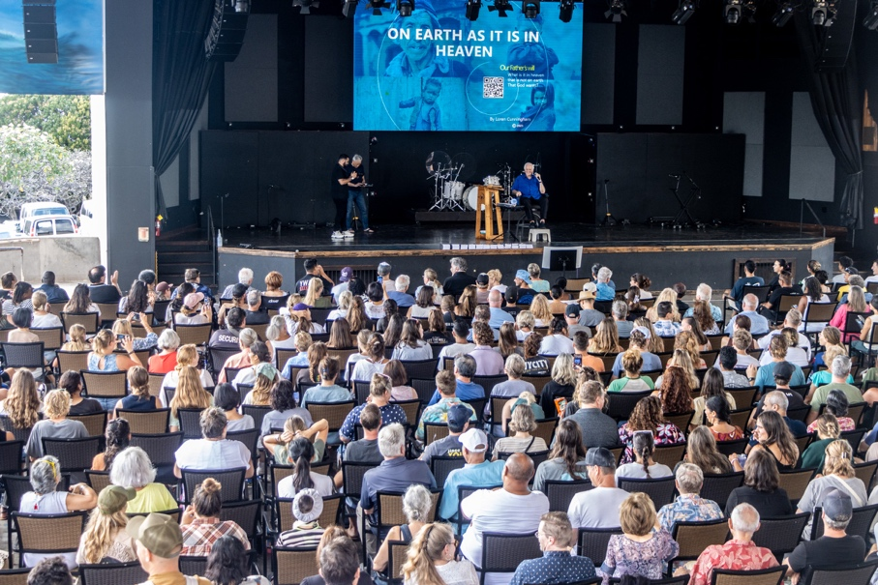

Since the 1960s, Loren has carried a burden with many other global leaders to make the Bible accessible to every person on earth, thereby ending Bible poverty worldwide. Wherever the Scripture goes, the Spirit of God brings transformation! He met with hundreds of influential leaders in evangelical, charismatic, and Pentecostal denominations and those leading the oldest Christian traditions to invite their partnership in this cause.

This passion became fine-tuned in his final years to focus on making an ORAL translation of the Bible available in each of the 8000+ MOTHER TONGUE languages on earth (PrayOMT.com). A person's mother tongue is the language that speaks straight to their heart, making this very important. The goal is to fulfill Jesus' prayer for God's will to be done "on earth as it is in heaven" (Matthew 6:10). And what is being done in heaven? According to Revelation 7:9, there is "a great multitude that no one could count, from every nation, tribe, people, and language, standing before the throne and before the Lamb.'"

In his final days, though his body was riddled with cancer, God energized Loren to "Zoom" with tens of thousands on every continent to share this passion. Just as he showed people how to live "full on" for Jesus, he also modeled how to faithfully finish the race God has set before each one of us. These were precious days of impartation into and prayer over the next generation and the next, who responded with an emphatic "yes - we accept and will carry out the call."
The future of YOUTH With A Mission, University of the Nations, and YWAM Ships is in good hands! The largest number of leaders and volunteers in YWAM are young. They are confident, capable and committed to leading YWAM into all God has for the coming 60+ years.
Loren's Background (LorenCunningham.com)

Born in Taft, California, Loren's family heritage was rich with generations of Christian ministers. He married Darlene Scratch in 1963, who had an equally rich Christian ministry background and complementary leadership call, and from that point, they led YWAM together. He was the apostolic visionary, and she was the people/team developer and implementer.

Loren's educational background includes three Bachelor's degrees, a Master of Science in Administration of Education, and three Honorary Doctorates. He authored six books: Is That Really You, God? (translated into more than 140 languages), Making Jesus Lord, Daring to Live on the Edge, Why Not Women?, The Book that Transforms Nations—the Power of the Bible to Change Any Country, We Can End Bible Poverty Now and No Boundaries.

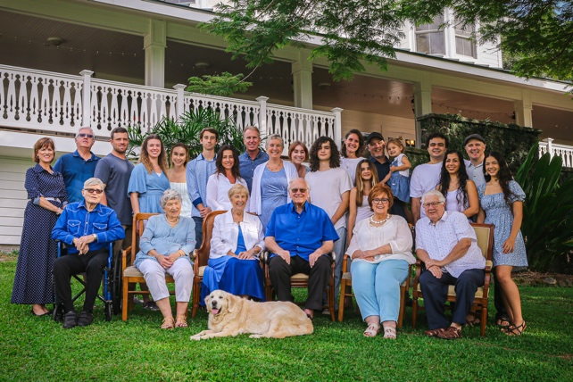
Loren is survived by his beloved wife, Darlene Joy Scratch-Cunningham; his daughter, Karen Joy Cunningham; his son, David Loren Cunningham (Judith Fitts-Cunningham); and three grandchildren, Madison Grace, Kenna Faith and Liam Reid.

- by Dawn Gauslin, International Assistant to Darlene Cunningham. Photo Credits: Susanne Childers & Dawn Gauslin
_________________

